**Question 1:**

* 1. Yes all of the tables exhibit entity integrity. They all have well defined and unique primary keys that uniquely identify each row or tuple.
  2. **Employee FK(s) = job_code**

employee(job_code) = $r_{1}$ referencing relation

job(job_code(pk)) = $r_{2}$ referenced relation

$r_{1} references r2$

**Benefit FK(s) = emp_code, plan_code (CMPK)**

Benefit(emp_code) = $r_{1}$ referencing relation

Benefit(plan_code) = $r_{2}$ referencing relation

Employee(emp_code(pk)) = $r_{3}$ referenced relation

Plan(plan_code(pk)) = $r_{4}$ referenced relation

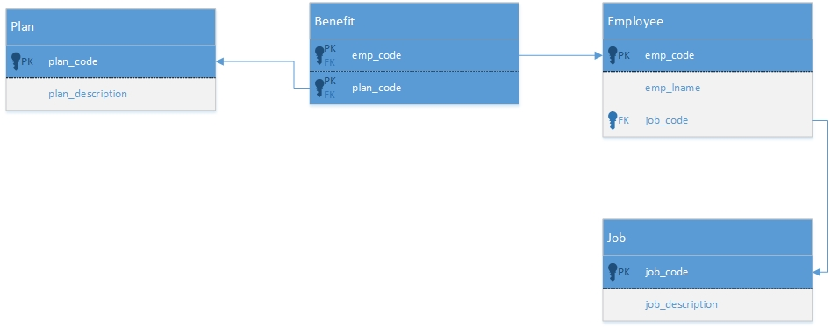

* 1. Yes, the tables exhibit referential integrity. Each foreign key points to a unique primary key in another table and those primary keys are referenced by unique foreign keys.

**Question 2:**

* 1. **Loan FK(s) = branch_id**

loan(branch_id) = $r_{1}$ referencing relation

branch(branch_id) = $r_{2} referenced relation$

$r_{1} references r_{2}$

**Borrower FK(s) = customer_id, loan_number (CMPK)**

borrower(customer_id) = $r_{1} referencing relation$

borrower(loan_number) = $r_{2} referencing relation$

customer(customer_id) = $r_{3} referenced relation$

loan(loan_number) = $r_{4} referenced relation$

$r_{1} references r_{3}$

$r_{2} references r_{4}$

**Depositor FK(s) = customer_id, account_number (CMPK)**

depositor(customer_id) = $r_{1} referencing relation$

depositor(account_number) = $r_{2} referencing relation$

customer(customer_id) = $r_{3} referenced relation$

account(account_number) = $r_{4} referenced relation$

$r_{1} references r_{3}$

$r_{2} references r_{4}$

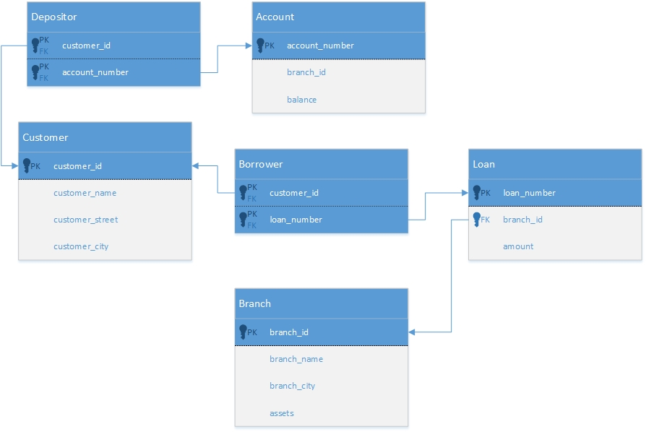

2.2

create database question2;

use question2;

create table Branch(branch_id int, branch_name varchar(25), branch_city varchar(25), assets decimal(13, 4), primary key (branch_id));

create table Customer(customer_id int, customer_name varchar(25), customer_street varchar(25), customer_city varchar(25), primary key (customer_id));

create table Loan(loan_number int, branch_id int, amount decimal(13, 4), primary key (loan_number) ,foreign key (branch_id) references Branch(branch_id));

create table Borrower(customer_id int, loan_number int, primary key (customer_id, loan_number), foreign key (customer_id) references Customer(customer_id), foreign key (loan_number) references Loan(loan_number));

create table Account(account_number int, branch_id int, balance decimal(13, 4), primary key (account_number), foreign key (branch_id) references Branch(branch_id));

create table Depositor(customer_id int, account_number int, primary key (customer_id, account_number), foreign key (customer_id) references Customer(customer_id), foreign key (account_number) references Account(account_number));

insert into branch values (1, 'First Bank of Ferenginar', 'Tower of Commerce', 9127854.32);

insert into branch values (2, 'Bank of Andor', 'Laikan', 19025465.23);

insert into branch values (3, 'Bank of Bolis', 'Bole', 57954895.23);

insert into customer values (00001, 'William Riker', '#1 1st street', 'Anchorage');

insert into customer values (00002, 'Quark', '285 Capitalism Way' , 'Tower of Commerce');

insert into customer values (00003, 'James T. Kirk', '51 W. 1st St' , 'Riverside');

insert into loan values (0258, 1, 150000.00);

insert into loan values (9458, 2, 23658.00);

insert into loan values (2236, 3, 1254874.00);

insert into borrower values (00001, 0258);

insert into borrower values (00002, 9458);

insert into borrower values (00003, 2236);

insert into account values (12345, 1, 455879.23);

insert into account values (65848, 2, 8965741.89);

insert into account values (96518, 3, 78945874.32);

insert into depositor values (00001, 12345);

insert into depositor values (00002, 65848);

insert into depositor values (00003, 96518);

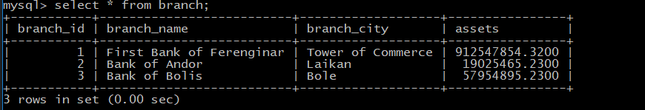

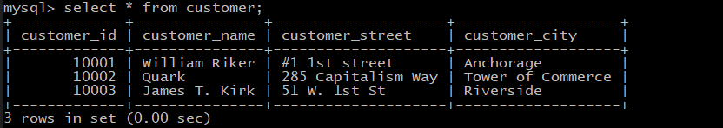

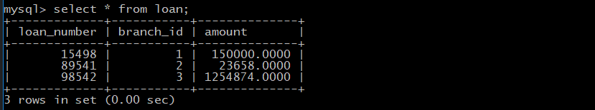

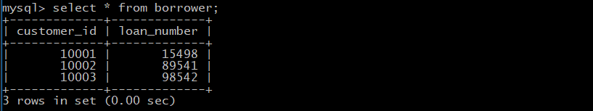

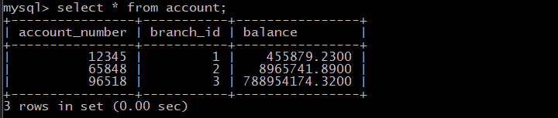

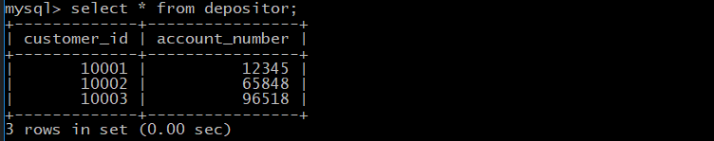

2.3

**1**

$Π_{customer_name}(σ_{customer_city=^{'}minneapolis^{'}}(Customers)$

**2**

$σ_{customer_name} ∧_{ customer_city}(Customer ⋈ Loans)$

**3**

$Π_{customer_name, customer_street, customer_city}(σ_{balance>10000}(Account)$

2.4

**1**

Find the branch names of all branches in Chicago

**2**

Find the loan number of any branch in Chicago that has a loan.